**Prototypes**

**Demo One:**

Link: <http://pictureintext.net/pro/Demo1/>

QR Code:

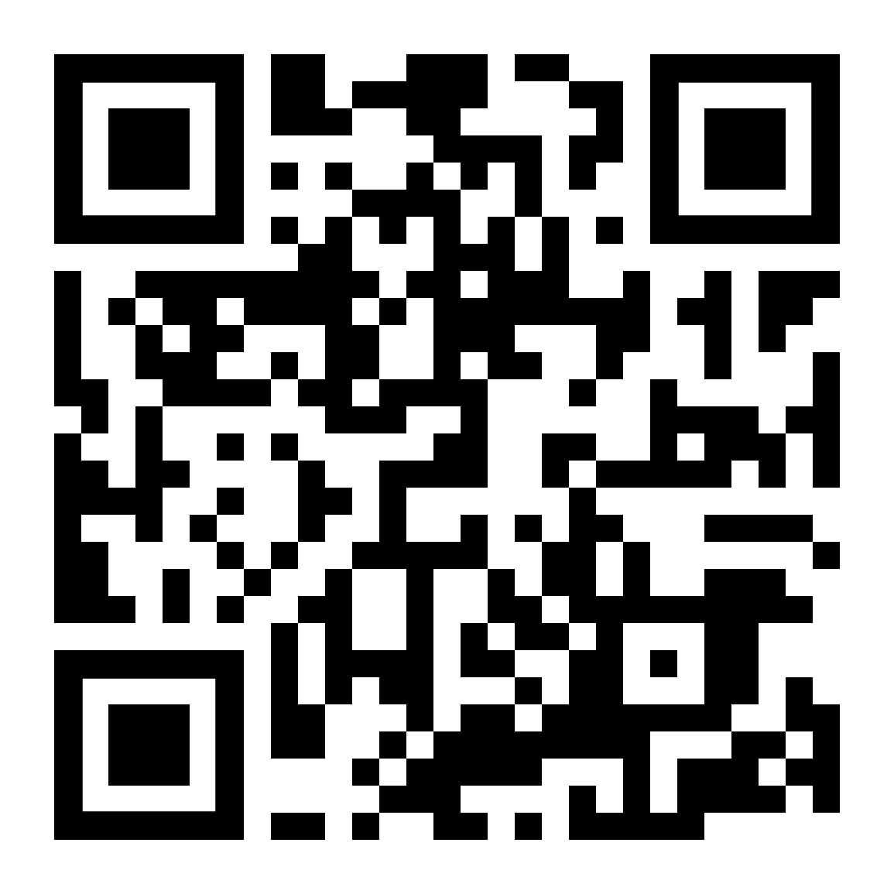

**Demo Two:**

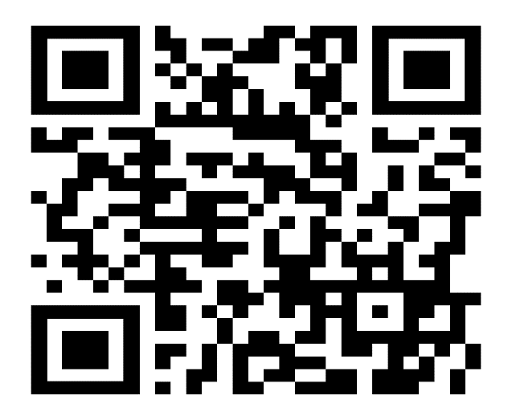Link: <http://pictureintext.net/pro/Demo2/>

QR Code:

**Demo Three:**

Link: <http://pictureintext.net/pro/Demo3/>

QR Code:

